**STILL ALIVE MEDICAL JOURNAL**

**Version 1.1**

**WOUNDS AND INFECTION**

Wounds come from three different sources: melee weapons, guns, and zombie bites.

Melee Weapons can only deal wounds to the chest of a player (When using the Harmful Weapons skill) [See **Harmful Weapons**]. These wounds can be healed by a doctor, but should be wrapped first. [See **Doctor** skill]. If you’ve been wounded by a melee weapon (been hit in the back and your attacker said the word “STRIKE” or if you’ve been hit by a “CRIPPLE” special attack), you’ll either fall helplessly to the ground holding your newly acquired chest wound, preventing yourself from bleeding out; or you’ll lose the ability to use the limb that was crippled. As will all chest wounds, you will not be able to get to the Doctor on your own, and instead will need to be dragged there by another person. A person cannot be killed by a melee weapon unless the attacker also possesses the skill Harmful Weapons and successfully finishes you off when you’re helpless on the ground [See **Harmful Weapons** skill]. A wound from a melee weapon should be wrapped by someone with the Medic or Field Medic skill before being taken into the Doctor to get it stitched up as it will become infected if you don’t; and that will cause your infection rating to go up [See **Medic** and **Field Medic** skills].

Wounds from a gun are described in detail in the above section about gun combat.

Wounds from a zombie are gotten from being latched onto by them. When you’ve received a wound from a zombie you can either have it wrapped by a Field Medic or Medic, or you can leave it and risk further infection, and both have their advantages [See **Medic** and **Field Medic** skills]. If you choose to have the wound wrapped, your limb will become incapacitated and you won’t be able to use it again until the wound is healed by a Doctor [See **Doctor** skill], however, once it’s wrapped, the wounded limb is immune to further infection and wounds. If you leave the wound unwrapped, you’ll retain full use of the limb, at the cost of possibly being bitten again.

Infection will happen slowly over time. When you return from a battle, the Doctor will look over everyone who was involved and determine the damage [See **Doctor** skill]. It’s your job to tell the Doctor how many times you were bitten on each limb. This is based on the honor system-The game is only as fun as you make it, so think twice before lying. Once the Doctor assesses you, they’ll refer to their infection chart to determine how many “infect dice” they’ll need to roll for you and, if the wounds are bad enough, if they’ll need to amputate. These dice will increase your overall infection rating.

Each character starts at 0% infection and will slowly gain it over time. To start out, every character rolls a 12-sided dice each time they need to roll an “infect dice” and the result is added to their infection rating (percentage). This dice can be reduced to a 10-sided, 8-sided, 6-sided and even 4-sided dice by taking the Infection Resistance skills [See **Infection Resistance 1, Infection Resistance 2, Infection Resistance 3,** and **Infection Resistance 4** skills]. It is your job to tell the doctor if you have any of these skills.

Once your infection rating reaches 25%, a percentage will be rolled to see if you begin to turn into a zombie. If you’re on the unlucky end of the deal, your character will become a zombie the next event and you’ll have to make a new one [See the **Death and New Characters** Section for more information]. This percentage roll is rolled once at 25%, once at 50%, and then at 75% it’s rolled at the end of every event. There *are* skills that can help you combat the infection’s hold on you, however. The Will to Live skills increase your chances of surviving [See **Will to Live 1** and **Will to Live 2** skills]. Will to Live 1 allows your character to roll the percentage again if they fail the first time, and Will to Live 2 gives the character a coin flip if they fail both percentage rolls-Heads means you live, tails means you turn into a zombie at the next event. And yes, this means that, even if a character had a 100% infection rating, they could still survive a few meets, provided they got lucky.

It’s important to note that if a player has a chest wound, you cannot move them from the spot they’re in without wrapping the wound first. They’ll bleed out and die if you don’t.

There are whispers about the hopes of a cure for the virus, or at least a way to reduce its infectious grasp on the world. Those that are interested in the cure will have to work long and hard in skills like Pharmaceuticals and Advanced Medical Research, but one day they could *hopefully* find a way to cure it [See **Pharmaceuticals** and **Advanced Medical Research** skills].

On the subject of Pharmaceuticals, there is currently one type that can be readily found in the world. It’s called Adreaniline and it pumps your body full of adrenaline. This pill is represented by orange tictacks and, when it’s rarely found, it can usually be purchased for 10 bullets. You may take each type of pharmaceutical ONCE per event, and only someone trained to handle them [See **Pharmaceuticals** skill] can administer them to other patients. Adreaniline allows you to completely ignore the EFFECTS of wounds for one full combat scenario, after which, you take the full effect of the wounds. This means that bites or wounds to the limbs or chest won’t affect you until after combat has ceased. **MEDICAL BAG**:

**For Medic Skill:**

Medical wraps, surgical scissors, cloth, and a small bottle full of water or a similar liquid [used as antiseptic or alcohol].

**For Field Medic Skill:**

Same as medic skill.

**For Doctor Skill:**

Same as medic skill, plus a Still Alive Medical Journal.

**For Surgeon Skill:**

Same as doctor skill plus an apron, and a medical mask.

**Medical Skills**

**Advanced Medical Research**

* + ***Prerequisites***: Pharmaceuticals, Surgeon
  + ***Cost/Tier***: 4
  + ***Description***: If a cure is ever going to be found, you’ll be the one to do it.
  + ***Explanation***: Allows the player to craft known Pharmaceuticals and discover new ones. This skill allows for other plot-related research as well, but we’re not going to give anything away!
  + ***Limitations***: None.
  + ***Type***: Profession
  + ***Notes***: None.

**Doctor**

* + ***Prerequisites***: Medic
  + ***Cost/Tier***: 3
  + ***Description***: Bring out yer dead.
  + ***Explanation***: Allows you to treat the wounds of players bitten by zombies and hit by melee weapons. You CANNOT treat bullet wounds. Treating a wrapped wound takes 2 minutes. Treating an unwrapped wound takes 5 minutes. Chest wounds always take 10 minutes to treat (Roleplay treating wounds).
  + ***Limitations***: Must have Medical Supplies bag on hand and all work must be done at camp. Additionally, the medical supplies back should contain the Still Alive Medical Journal.
  + ***Type***: Profession
  + ***Notes***: None.

**Field Medic**

* + ***Prerequisites***: Medic
  + ***Cost/Tier***: 2
  + ***Description***: What’s better than medical wraps? Mobile medical wraps!
  + ***Explanation***: An upgrade to the Medic skill. This skill allows you to wrap a single wound per limb of a wounded ally. Wrapping a wound requires a wrap from a medical kit to be tied around the corresponding wound. Wrapping a wound requires 10 seconds and renders the limb unusable until treated by a doctor or surgeon back at camp. However, a wrapped wound is immune to further damage and infection. You may also wrap your own wound, but it takes twice as long (20 seconds).
  + ***Limitations***: In order to use any medical skill, a medical kit is required. A medical kit must consist of medical wraps, surgical scissors, cloth, and a small bottle full of water or a similar liquid [used as antiseptic or alcohol]. If you run out of medical wraps, you cannot wrap wounds.
  + ***Type***: Talent
  + ***Notes***: None.

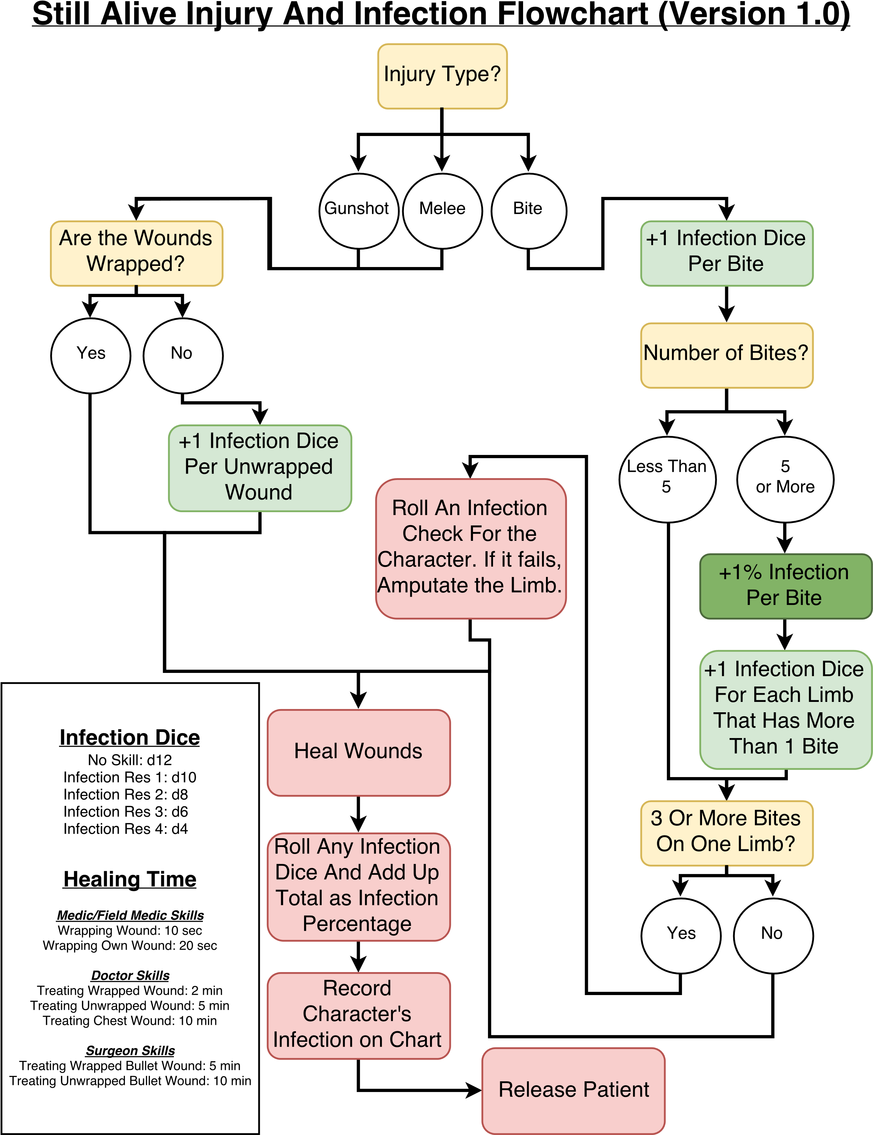

|  |  |  |
| --- | --- | --- |
| **PLAYER NAME** | **CHARACTER NAME** | **INFECTION AMOUNT** |
|  |  |  |
|  |  |  |
|  |  |  |
|  |  |  |
|  |  |  |
|  |  |  |
|  |  |  |
|  |  |  |
|  |  |  |
|  |  |  |
|  |  |  |
|  |  |  |
|  |  |  |
|  |  |  |
|  |  |  |
|  |  |  |
|  |  |  |
|  |  |  |
|  |  |  |
|  |  |  |
|  |  |  |
|  |  |  |
|  |  |  |
|  |  |  |
|  |  |  |
|  |  |  |
|  |  |  |
|  |  |  |
|  |  |  |
|  |  |  |
|  |  |  |
|  |  |  |
|  |  |  |
|  |  |  |
|  |  |  |
|  |  |  |
|  |  |  |
|  |  |  |
|  |  |  |
|  |  |  |
|  |  |  |
|  |  |  |